# الاسم :محمد رمضان الطيب علي احمد

# NAME :MOHAMED RAMADAN ELTAYEP ALY

# BN:706

# TOPIC : ARTIFICIAL INTELLIGENCE

# APPLICATION BRIEF:

AI is the branch of computer science that aims to answer Turing's question in the affirmative. It is the endeavor to replicate or simulate human intelligence in machinesThe expansive goal of artificial intelligence has given rise to many questions and debates. So much so, that no singular definition of the field is universally accepted. ARTIFICIAL INTELLIGENCE IS THE FUTUR OF ALL THE FIELDS .ARTFICIAL INTELLIGECE MAKE THE LIFE SO HAPPY AND NO EXAUSTED SOTHAT I CHOOSE THIS TOPIC .

# Screenshots:

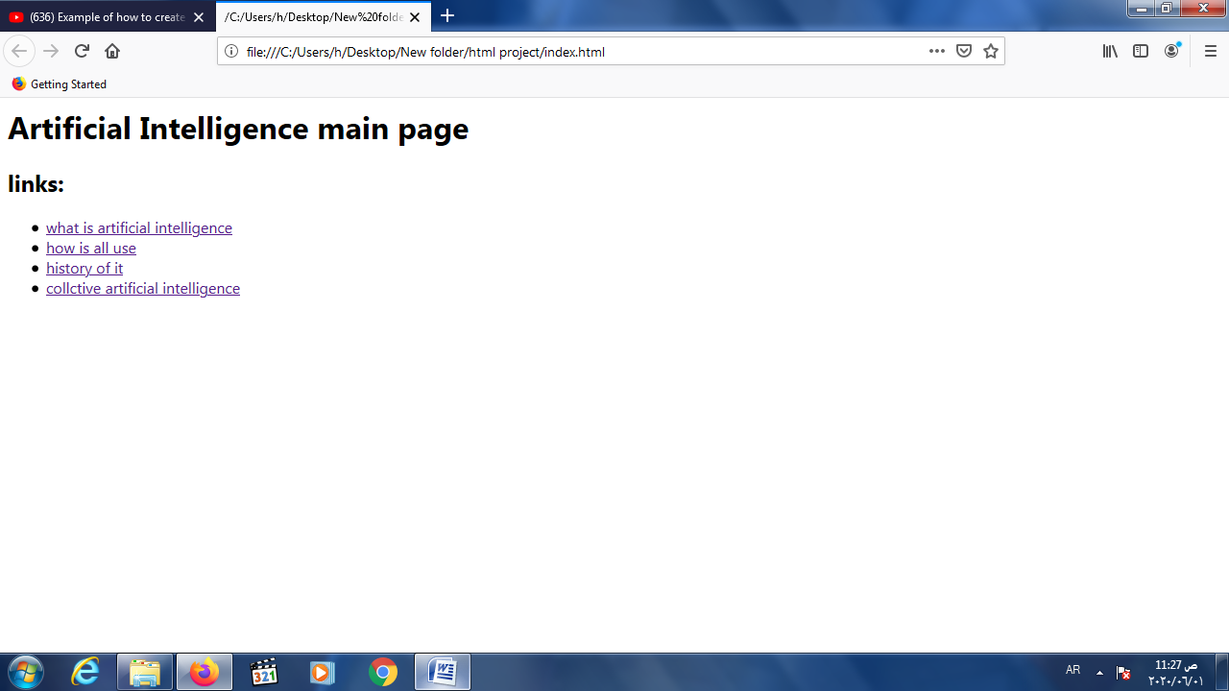

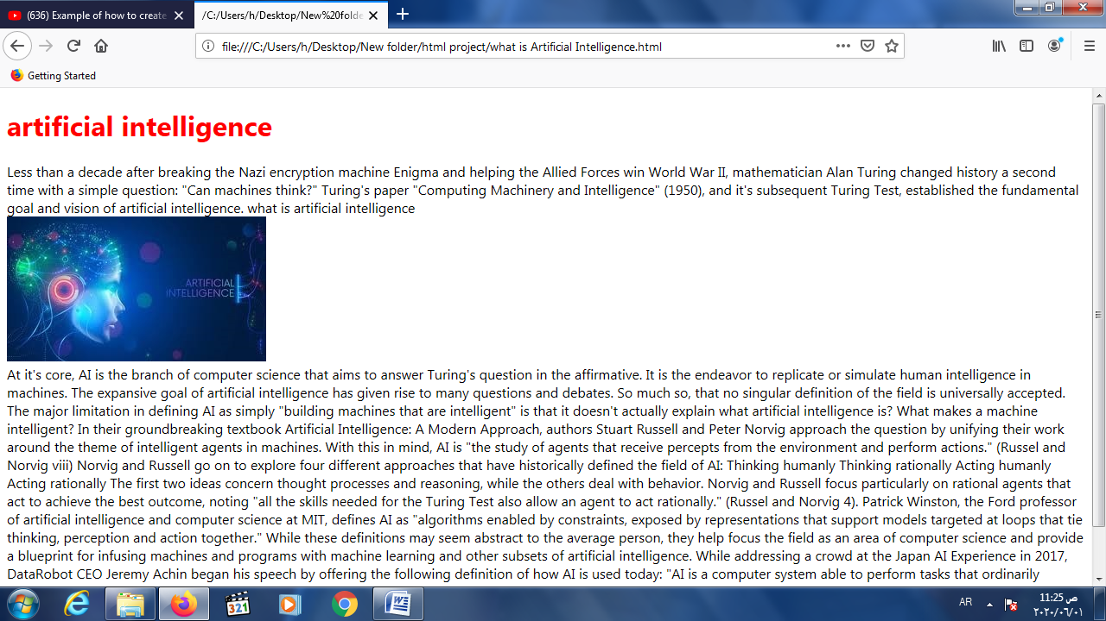

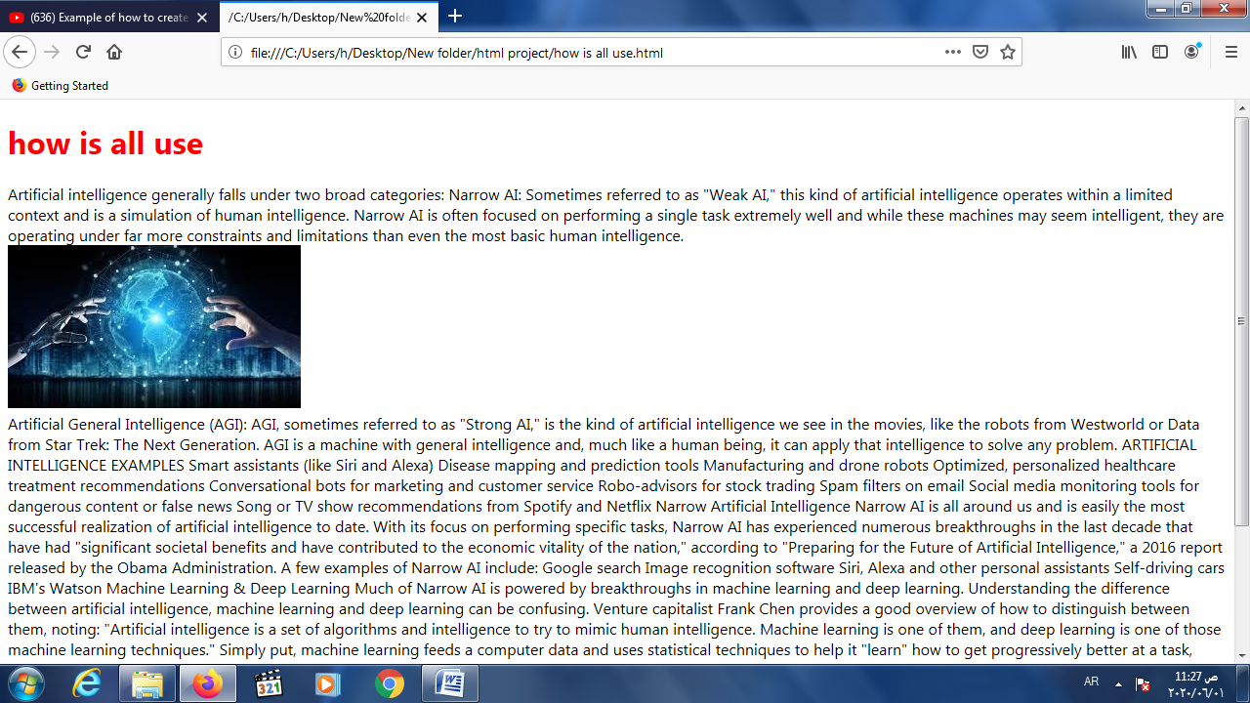

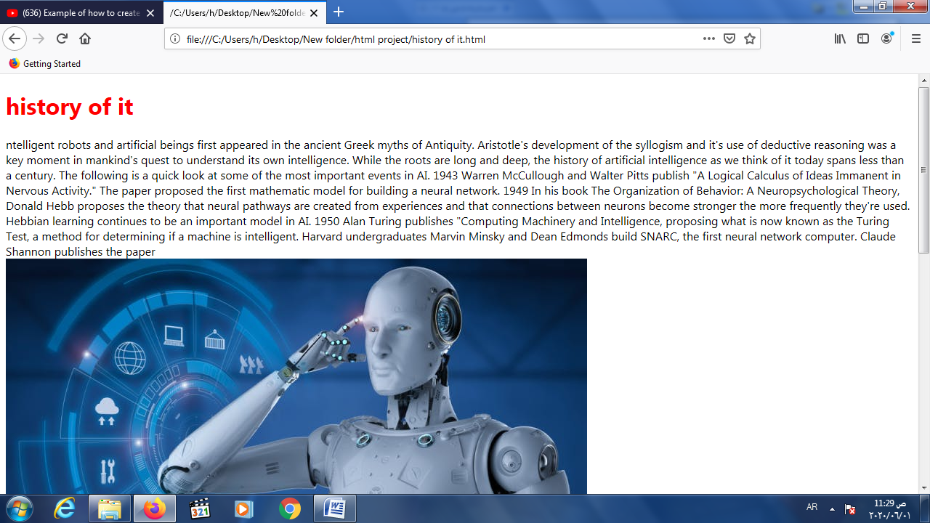

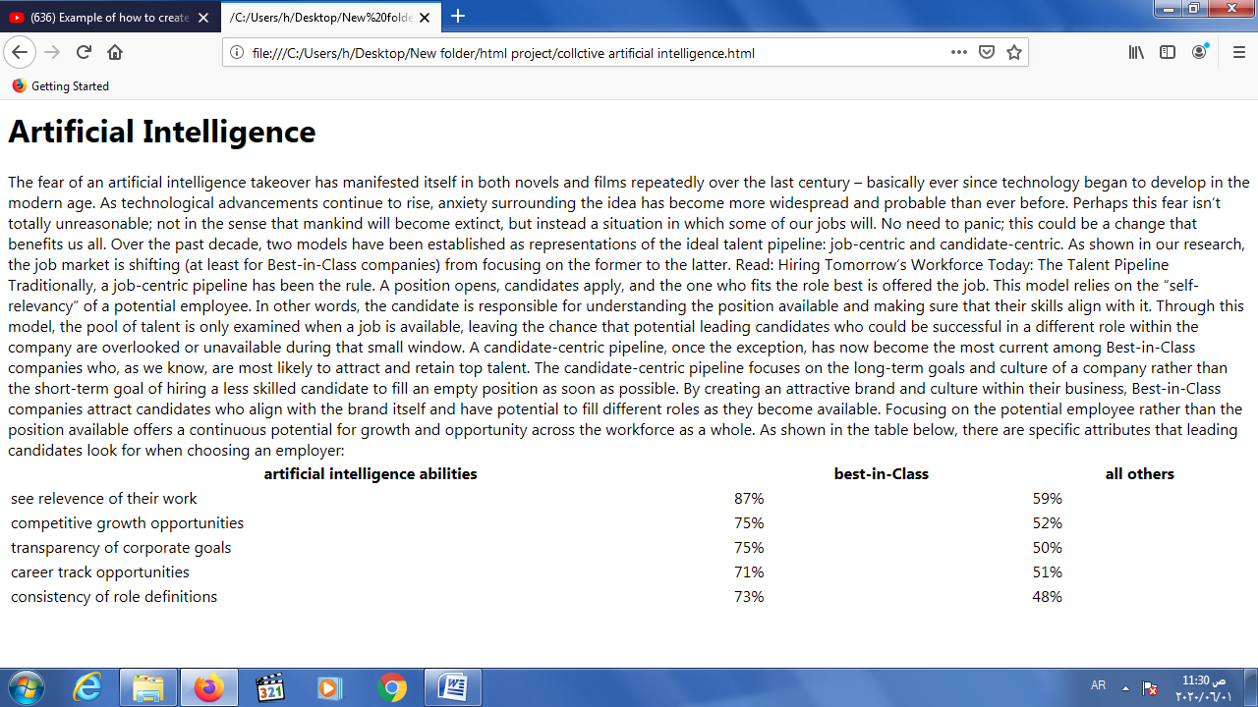

## Source code

# 